|  |  |
| --- | --- |
| **AP Computer Science** | **TextLab09 Java Assignment** |
| **The Matrix Program** | **80 and 100 Point Versions** |
| **Assignment Purpose:**  Students will become proficient with redefining **Object** class methods. | |

In this program you are provided with a fundamental **Matrix** class. The class has few methods. In this assignment you need to make the Matrix class more practical by redefining the **toString** method and the **equals** method.

|  |  |
| --- | --- |
| **TextLab09 Student Version** | **Do not copy this file, which is provided.** |
| // TextLab09st.java  // This is the student, starting file of the TextLab09 assignment.  import java.util.Random;  public class TextLab09st  {  public static void main(String args[])  {  System.out.println("TextLab09\n\n");  Matrix m1 = new Matrix(3,4,1234);  Matrix m2 = new Matrix(3,4,1234);  Matrix m3 = new Matrix(3,4,4321);  System.out.println("Matrix m1\n");  System.out.println(m1+"\n\n");  System.out.println("Matrix m2\n");  System.out.println(m2+"\n\n");  System.out.println("Matrix m3\n");  System.out.println(m3+"\n\n");  if (m1.equals(m2))  System.out.println("m1 is equal to m2\n");  else  System.out.println("m1 is not equal to m2\n");  if (m1.equals(m3))  System.out.println("m1 is equal to m3\n");  else  System.out.println("m1 is not equal to m3\n");  }  }  class Matrix  {  private int rows;  private int cols;  private int mat[][];  public Matrix(int rows, int cols, int seed)  {  this.rows = rows;  this.cols = cols;  mat = new int[rows][cols];  Random rnd = new Random(seed);  for (int r = 0; r < rows; r ++)  for (int c = 0; c < cols; c++)  {  int randomInt = rnd.nextInt(90) + 10;  mat[r][c] = randomInt;  }  }  } | |

**TextLab09st Current Output**

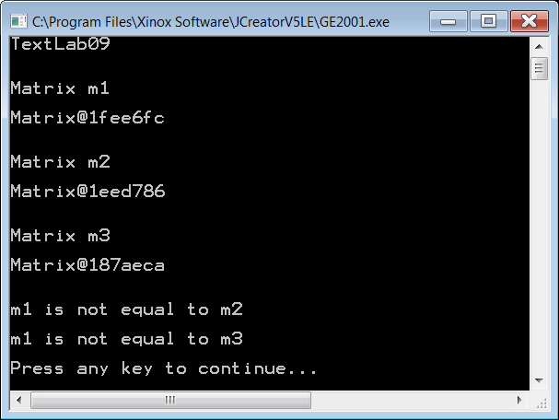

The current output shows that the **toString** method displays the memory addresses of its objects. This indicates that the **toString** method is not redefined.

For the **80-point** version you need to add a **toString** method that will display the values of the matrix in a standard two-dimensional row X column display.

You will note that none of the Matrix objects appear equal. Equality for this assignment will mean that two matrix objects are the same dimensions and store the same values. For the **100-point** version you need to redefine the **equals** method so that **Matrix** objects are correctly compared.

**80 Point Version Output**

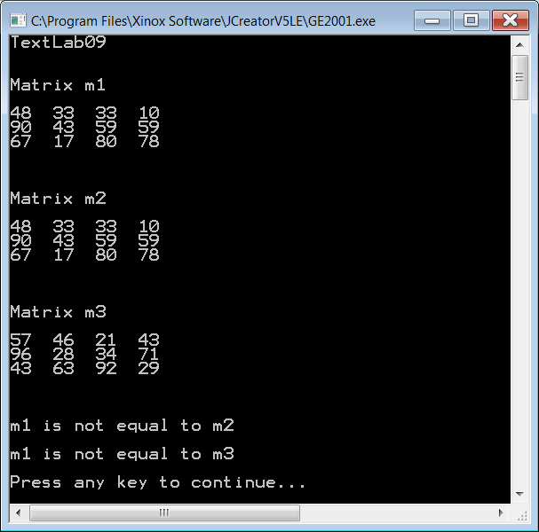

**100 point Version Output**

